Procedural Sedation - Ketamine

Definition of Dissociative Sedation
A trancelike cataleptic state induced by the dissociative agent ketamine, characterized by profound analgesia and amnesia, with retention of protective airway reflexes, spontaneous respirations, and cardiopulmonary stability.

Characteristics of the Ketamine “Dissociative State”
- Dissociation: After administration of ketamine, the patient passes into a fugue state or trance. The eyes may remain open, but the patient does not respond.
- Catalepsy: Normal or slightly enhanced muscle tone is maintained. On occasion, the patient may move or be moved into a position that is self-maintaining. Occasional muscular clonus may be observed.
- Analgesia: Analgesia is typically substantial or complete.
- Amnesia: Total amnesia is typical.
- Maintenance of airway reflexes: Upper airway reflexes remain intact and may be slightly exaggerated. Intubation is unnecessary, but occasional repositioning of the head may be necessary for optimal airway patency. Suctioning of hypersalivation may occasionally be necessary.
- Cardiovascular stability: Blood pressure and pulse rate are not decreased and typically are mildly increased.
- Nystagmus: Nystagmus is typical.

Indications
- Short, painful procedures, especially those requiring immobilization (fracture reduction, large complex laceration repair, abscess incision and drainage, tube thoracostomy, emergency airway procedures).
- Orthopedic management: for reduction of long bone fractures or joint dislocations where operational circumstances do not allow quick evacuation times or there is neurovascular compromise as a direct result of the injury.
- Wound management: for management of large, complex wounds requiring packing or dressing changes in situations where there is no option of quick patient evacuation.
- Any situation requiring medical management, even monitoring and observation, where the patient is combative and risks harm to himself/herself by interfering with delivery of medical care.
- Emotionally disturbing procedures (i.e. pediatric)

Contraindications:
- Age younger than 3 months
- Known or suspected schizophrenia
- Hx of airway instability (Relative)
- Active pulmonary infection/disease/asthma (Relative)
- CNS abnormalities-Incr ICP with Ketamine (Relative)

Personnel
This is a 2-person procedure, one (nurse / Med Tech) to monitor the patient and one (PA) to perform the procedure.

Minimum requirements to perform procedural sedation
1. Detailed knowledge of medications used
2. Pulse oximetry with continuous monitoring
3. NIBP measuring ability
4. Advanced airway management skills and equipment
5. BVM
6. Good IV/IO access (IM if unable to obtain IV/IO). Note that IV/IO is the preferred route of medication administration.
7. End-tidal CO2 detector (if available)
8. Suction device (if available)
9. Supplemental oxygen (if available)

Pre-sedation procedures (See note page)
- Prepare medications for administration at appropriate concentrations as per desired route of administration (see notes page):
Midazolam (supplied as 5mg/ml):
    - diluted to1 mg/ml for IV/IO; OR
    - undiluted 5mg/ml for IM.

Ketamine (supplied as 50mg/ml):
- diluted to 10mg/ml for IV/IO; or
- undiluted 50mg/ml for IM.

Ketamine Administration: General
- Ketamine is not administered until the PA is ready to begin the procedure as onset of dissociation occurs rapidly.
- Ketamine is initially administered as a single IV loading dose or IM injection. There is no benefit from attempts to titrate to effect.
- IV route is preferable because recovery is faster and there is less emesis.
- The IM route is especially useful when IV/IO access cannot be consistently obtained with minimal upset, and for patients who are uncooperative or combative. IV access is unnecessary for children receiving IM ketamine. Because unpleasant recovery reactions are more common in adults, IV access is desirable in these patients to permit rapid treatment of these reactions, should they occur.

Procedure
- Continuous oxygen saturation monitoring and other vital sign (RR, HR, BP) monitoring q 1 min intervals at minimum while delivering medications. In recovery phase monitoring may be q 5 min intervals.
- Administer supplemental oxygen by mask or nasal prongs if available.
- Prepare ketamine and midazolam for administration at appropriate concentrations as per desired route of administration (refer to notes page).

- Suction equipment, BVM, and equipment for advanced airway management should be immediately available.
- Secure intravenous access if possible
- Administer midazolam 2mg IV/IO or midazolam 5mg IM
- Immediately follow with Ketamine 1mg/kg IV/IO or Ketamine 5mg/kg IM
- Assess patient’s response to medications, onset of action will take 1 min for IV preparations and 2-3 mins for IM preparations – if sedation deemed adequate, proceed with medical interventions.
- If sedation is not adequate, then provide additional ketamine as per flow chart

Post Procedure
- After the procedure has been performed, continue to administer supplemental oxygen and monitor vital signs q 5 mins for 30 mins and then q 15 mins for a total of 60 mins from last administration of sedative medication.

Discharge Criteria /Instructions
- Return to pre-treatment level of verbalization/awareness and neuromuscular activity
- Nothing by mouth for approximately 2 hours
- Careful family and/or military medical observation and no independent ambulation for approximately 2 hours

Co-administered Medications
- Prophylactic midazolam can reduce the rate of emergence reaction.
- Prophylactic ondansetron can reduce the rate of vomiting. Administer 8mg (4mg peds) po 30 min prior to procedure or 4-8mg IV/IO over 15 min.

Potential Adverse Effects
- Airway misalignment requiring repositioning of head (occasional)
- Transient laryngospasm (0.3%)
- Transient apnea or respiratory depression (0.8%)
- Hypersalivation (rare)
- Emesis, usually well into recovery (8.4%)
- Recovery agitation (mild in 6.3%, clinically important in 1.4%)
- Muscular hypertonicity and random, purposeless movements (common)
- Clonus, hiccupping, or short-lived non-allergic rash of face and neck

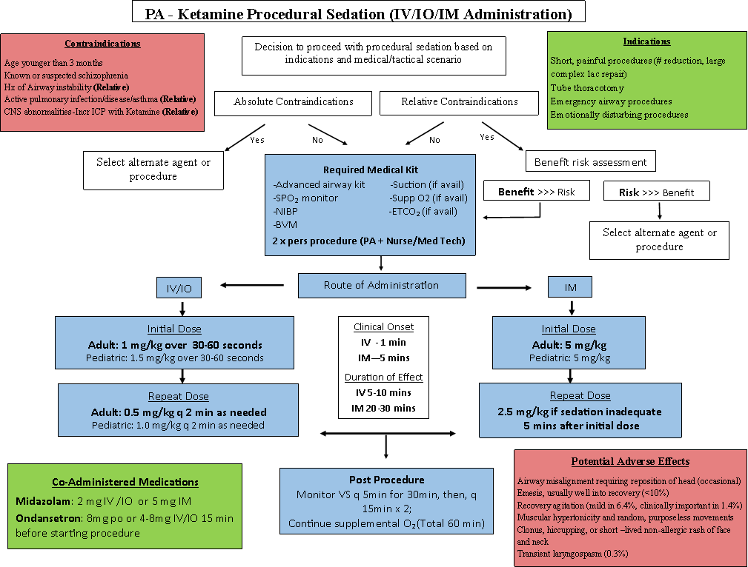
NOTES:
Ketamine Preparation
- Label two or three 10cc syringes
- Draw up 100mg of Ketamine in each syringe (2ml of 50mg/ml stock)
- Dilute w/ NS to 10cc (= 10ml @ 10mg/ml)
Midazolam Preparation
- Label one 5cc syringe
- Draw up 5mg of Midazolam (1.0ml of 5mg/ml stock)
- Dilute w/ NS to 5cc (=5ml @ 1.0mg/ml)

The following table should be used as a guide to convert pounds to kilograms and to determine respective IV/IO and IM weight based ketamine dosing:
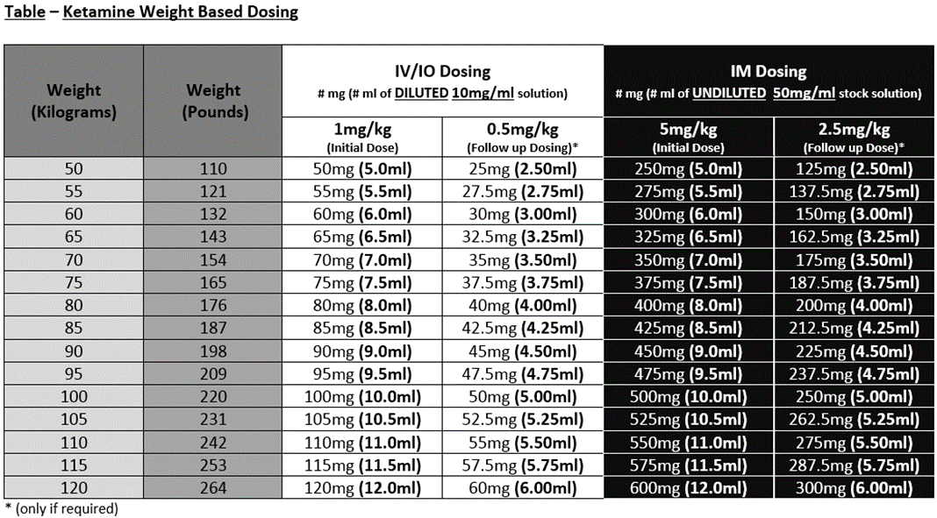
*For IV/IO administration in patients weighing > 80 kg, 3 x 10cc syringes should be prepared (80kg x 2.5mg/kg = 200mg = Full contents of 2 x 10cc syringes). 3 syringes (300mg) will provide a 2.5mg/kg supply for patients weighing up to 120kg.
*Observe for increased secretions or laryngospasm (When respiratory depression is noticed, it is invariably at the time of peak central nervous system levels (e.g. 1-2 minutes after IV/IO administration and 4-5 minutes for IM). - Ann Emerg Med. 2011; 57: 449-461). Be prepared to reposition airway, suction or use BVM to resolve transient laryngospasm. Signs of lightening sedation include nystagmus, vocalizations and/or increasing movement.

